Running Head: FORMULA RACING

Formula Racing
Student’s Name
Institutional Affiliation
Date

Formula Racing
The full term formula racing relates to a certain kind of motor racing which puts together a single seater and an open wheeled chassis for motorsport road racing. It is also a collection of motor-powered vehicles with their wheels outside and not certain by any bodywork of the car. The origin of this term is based on the terminology that was adopted by the Federation Internationale de I'Automobile (FIA) for all of its post- World War II single seater rules. These have been categorized universally as specific ‘formula' successions and the most mutual types of series being Formula One, and many others plus the likes of Formula 3, Formula Ford, Formula Renault and Formula Palmer Audi. The mutual usage of the "formula racing" incorporates about of the other single-seater successions such as the GP2 successions that in turn substituted the Formula 3000. In up-to-date times some of the new open-wheeled successions that have been shaped from Europe have misplaced the ‘Formula' autograph such as the GP2 and GP3 (Marino et al. 2015).
Some classification such as the Formula 3 and the Formula 2 tournament are known as the Feeder formulae, that denotes to their point below Formula One on the career hierarchy of the single seater motor sport. There are two important forms of competition Formula which comprise the open Formula that permits choice of engine and the regulator or "specs" formula that depends on a solo supplier for engine and framework. The Formula Three is an outstanding example of an open method whereas on the other hand, the Formula BMW is a regulator formula. These two forms also have some exclusions such as the Formula Ford in which there is an open framework formula but a constrained single brand engine formula (Aversa, Furnari, & Haefliger, S. (2015).
The various forms of Formula racing are;

a) Formula One
This is the highest form of single seater auto racing governed by the Federation Internationale de I'Automobile (FIA) and owned by the Formula One group. The formula rules have stringent rules that sanction car power, mass and size. The FIA Formula One World tournament has been one of the chief forms of competing around the world since its opening season in 1950. The name formula in its designation represents the set of guidelines in which all participants' cars must observe to (Bisagni et al. (2005).
A Formula One successions comprises a successions of races that are known to as the Grand Prix that are usually held universal on purpose-built tours and public roads. The result of each of the pathways is assessed using a fact system that regulates two yearly world tournaments, one for the drivers, the other for builders. The drivers are obliged to hold valid Super warrants, that is the uppermost class of contesting license issued by the FIA. Most of the happenings are held in rural settings on purpose-built roads but still some of the games at times are held on the city streets.

History of Formula One
Formula One can trace back its roots way back to the earliest days of motor racing, and it came from the European racing scene from the inter-wars back then. The plans for the Formula One driver’s championship planned in the 1930s, but the onset of World War Two shelved them.
During 1946 the notion was revived, and in that period the first races took place, and the following year it came to an agreement to launch a drivers' championship. It took time until 1950 that is when the details were hammered out, and in May 1950 the first championship race worldwide was held in Silverstone (Incandela, S. (1990).
Some Grand Prix competing organizations had laid out rules for a worldwide tournament before the war, but since the suspension of racing at the time of the battle, the world Drivers championship was not formalized until the year 1947. National tournaments race existed in South Africa and the UK during the 1960s and 1970s. Non-championship Formula One event took place for many years, however, due to the cumulative cost of the rivalry, the last of these took place during 1983. On the 26 November of the year 2017, Formula One free its new logo, following the 2017 periods finale in Abu Dhabi during the Abu Dhabi Grand Prix at Yas Marina Circuit. The brand new logo has taken the place of the F1’s iconic ‘flying one’ which was the sport’s trademark since 1993 (Issakhanian et al. (2010).

b) Formula E
Formula E is a collection of open-wheel auto contesting that uses only electric powered vehicles.
This type of series was initiated in the year 2011, and the initial championship started in Beijing in September 2014. The tournament was intended by the FIA to serve as an R&D podium for the electric vehicle and promote interest in EVs and sustainability. This type of series races majorly on short tours in towns such as New York, Hong Kong, Zurich, Berlin,
Rome and Paris in the events known as “ePrix”. To reduce the amount of cost but still maintain technological development, this type of series uses a spec chassis and a battery that is supposed to be used by all the entrants, with the competing teams permitted to design and build their motors, inverter and the rear suspensions. This type of series has gained very significant traction in recent years (Wright, 1982).

The History of Formula 2
The notion about formula E originated on a napkin during an evening meal and over recent years has developed from a brave experiment to a significant aspect of the motorsport scene. Since 2014 the Drivers and their teams have been competing against one another in their electric cars in the world’s major cities. The suggestion of a city-based single-seater electric car motor racing championship was conceived by Jean Todt, the president of the world leading body of motorsport, the Federation Internationale de I'Automobile (FIA) and showed the idea to the politicians Alejandro Agag and Antonio Tajani at a dinner at a small Italian cafeteria in the French capital of Paris on 3rd March 2011. Tajani was further keen on the electrification of the motor businesses, dropping the amount of carbon dioxide releases and presenting hybrid and electric systems. Agag was in line with Todt's suggestion after the latter deliberated the FIA opening up a warm reception to organising the successions. Agag thus told Todt that he would commence the risk since his previous familiarity in conveying contracts with television locations, sponsorships and advertising (Matthews, 2001).
Ten teams with two motorists each currently compete the Formula E championship. The fast mounting sport topographies electric-powered race cars of stylistic resemblance to the non-electric cars of Formula One. A distinctive Formula E cars contains a power of not less than 250 horsepower (190Kw). The car can accelerate from 0-100km/h (0-60 mph) in 3 seconds, with a maximum speed of 225km/h (140 mph). The designers that are used to recharge the batteries are power-driven by glycerin, an offshoot of biodiesel invention.
Since the second season, regulations allow new powertrain builders, who can build the electric motor, inverter, gearbox and cooling system; the framework and battery remain as they were: Initially, there were nine producers making powertrains for the 2016-17 season: ABT Schaeffler, Andretti Technologies, DS-version, Jaguar, Mahindra, Next TCR, Penske, Renault and Venturi.

© Formula 2
Formula 2 is an open-wheel racing category that serves as the second tier of formula racing in the FIA Universal pathway. This category is planned to be run in provision of the 2018 FIA Formula One World Tournament, with each of the twelve times running in connection with a Grand Prix. The current overriding Driver’s champion is Charles Leclerc, seeing that he won the trophy at the last but one round of the 2017 tournament in Jerez de la Frontera. Leclerc will not go back to defend his trophy as he will graduate to Formula One. Presently, the governing teams champion are the Russian time partaking protected their first Formula 2 claim at the last round of the 2017 tournament in Abu Dhabi. After ten rounds, George Russell leads the tournaments for Drivers being ahead with 37 points, ahead of such people like Alexander Albon.

The halo was put in place to improve the safety values by swerving debris away from a driver’s head and was originally put in place for use in Formula One before its appeal was inflamed to the other open wheel competitions and it was integrated into the final development of the
Dallara F2 2018 charter. Following the expedient broad range appraisals of the Dallara F2 2018 for its challenging start technique and reliability issues, the competition momentarily familiarized developing twitches until a better response to the car’s glitches could be found.
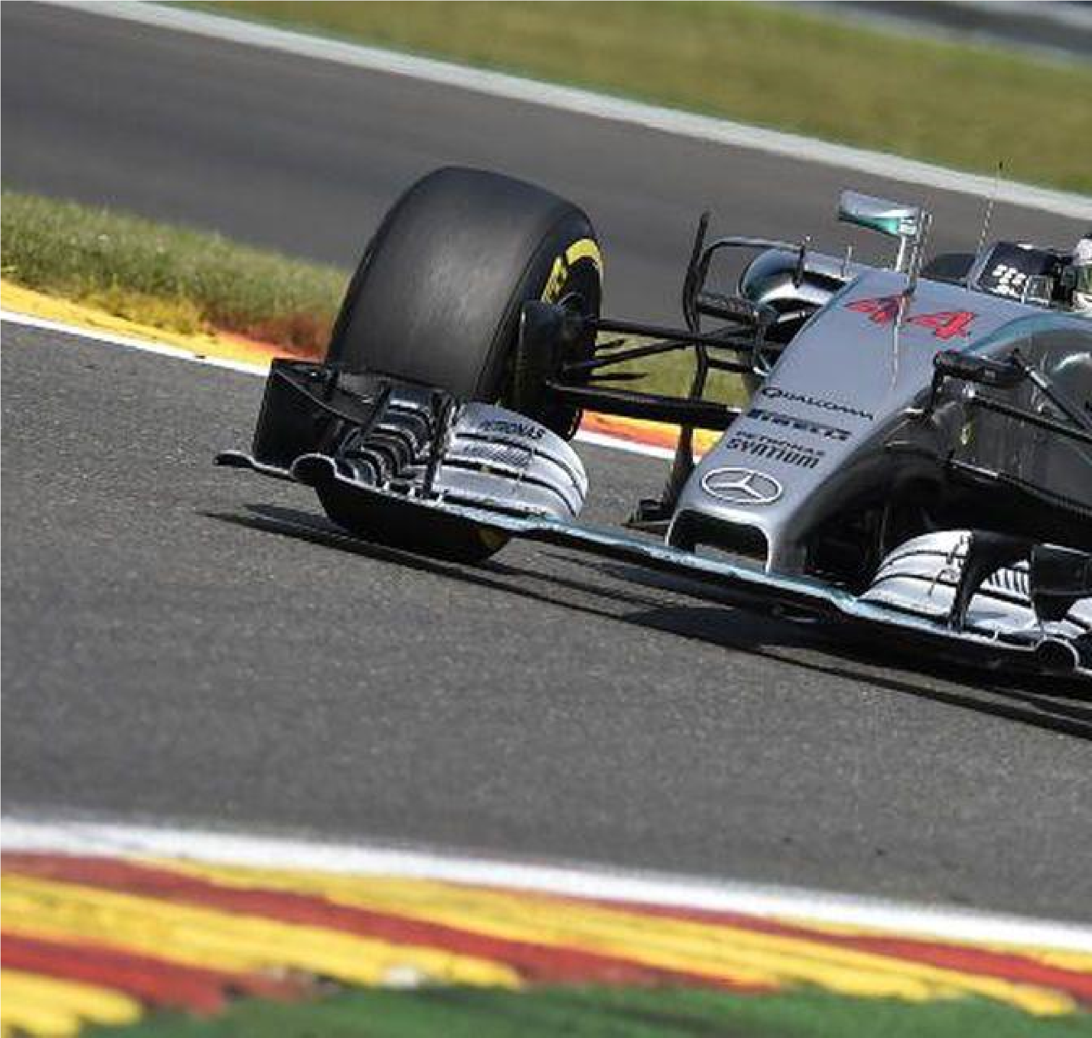
Mercedes AMG Petronas F1 Team's British driver Lewis Hamilton at the Spa-Franco champs circuit in Spa on August 23, 2015, during the Belgian Formula One Grand Prix. AFP PHOTO /
JOHN THYS (Photo credit should read JOHN THYS/AFP/Getty Images)

Formula One auto racing doesn’t spring to mind when bearing in mind which sports are the most maintainable. Others such as cycling, golf or tennis appear more likely contenders than one whose partakers race 19 times a year in cars with 1.6 litre V6 turbo engines. However, closer scrutiny under F1’s hood reveals that when it comes to sustainability, not only does it punch above its weight, it may be in pole position.
There are four foundations to F1’s mantle as sport’s sustainability champion:
environmental, economic, educational and safe. F1 may seem like a gas guzzling race series, but in fact, it has been driving to reduce its carbon footprint over the past five years. In 2010 its teams announced that they planned to slash carbon emissions within three years. Unlike many goals set by sports teams, this one was met.
In 2013 a review carried out by ecological research analysis organisation, Trucost exposed that the teams’ carbon productions had changed by 7% amid 2009 and 2011. The climax was a 24% decrease in carbon productions from the cars themselves due to augmented fuel competence and expansions such as the Kinetic Energy Recovery System (KERS) that stores energy made under decelerating to give an improvement on speeding up. Ever since 2014, the cars have turned even additional fuel efficient as their 2.4 litres V8s were substituted with 1.6-litre V6 turbos. The brand engines come whole with energy retrieval systems that allow the cars to complete races consuming no more than 100kg of fuel - around 35% less than the prior power units.
Formula One auto racing doesn’t logically spring to notice when bearing in mind which sports are the most maintainable. Others such as cycling, tennis or golf seem more likely participants than one whose contestants race 19 times a year in cars with 1.6 litre V6 turbo engines. Nevertheless, closer checkup under F1’s cover reveals that when it comes to sustainability, not only does it blow above its mass, it can be in pole locus. In the latest years’ durability has developed closely associated with ecological friendliness, and a longing to lessen carbon productions but in fact, it means much more than that.
There are four fundamentals to F1’s veil as sport’s sustainability victor: environmental, economic, educational and safety. F1 may look like a gas consuming race chains, but in fact, it has been driving to lessen its carbon footmark over the previous five years. In 2010 its players announced that they deliberated to slit carbon productions within three years. The Mercedes SClass is in a row on a 6-cylinder turbo engine, and the means we adjust our drivers regarding efficiency and control placement translates unswervingly into road cars,” says Mr Wolff. “It is all sense of the growth on track unconditionally. So that is trendy. It isrealism, and this is why the crossbreed 6-cylinder turbo engines are so significant for us.” It gives F1 the control to make millions of cars all over the sphere greener thereby plummeting productions on a far superior scale than the sequences itself could ever hope to attain. This effect is exaggerated by the fact that Mercedes isn’t the only worldwide auto producer in F1 as Ferrari, Honda and Renault likewise build its engines.
In summary, motorsport has been a close game in different countries. The science behind Formula racing has dramatically changed the course of events. Most people have made a living out of this sport by winning titles. Vagaries of nature have also impacted this sport. However, much is expected in the coming years.
Work Cited
Aversa, P., Furnari, S., & Haefliger, S. (2015). Business model configurations and performance:
A qualitative comparative analysis in Formula One racing, 2005–2013. Industrial and Corporate Change, 24(3), 655-676.
Bisagni, C., Di Pietro, G., Fraschini, L., & Terletti, D. (2005). Progressive crushing of fiberreinforced composite structural components of a Formula One racing car. Composite structures, 68(4), 491-503.
Incandela, S. (1990). The anatomy & development of the Formula One racing car from 1975.
Haynes.
Is Formula One The World’s Most Sustainable Sport?
https://www.forbes.com/sites/csylt/2015/08/25/is-formula-one-the-worlds-mostsustainable-sport/#894cc082952b
Issakhanian, E., Elkins, C. J., Lo, K. P., & Eaton, J. K. (2010). An experimental study of the flow around a formula one racing car tire. Journal of Fluids Engineering, 132(7), 071103.
Marino, A., Aversa, P., Mesquita, L., & Anand, J. (2015). Driving performance via exploration in changing environments: Evidence from formula one racing. Organization Science, 26(4), 1079-1100.
Wright, P. G. (1982). The influence of aerodynamics on the design of Formula One racing cars.
International Journal of Vehicle Design, 3(4), 383-397.

12

Wright, P., & Matthews, T. (2001). Formula 1 technology. Warrendale, PA: Society of Automotive
Engineers, 2001. 454.

